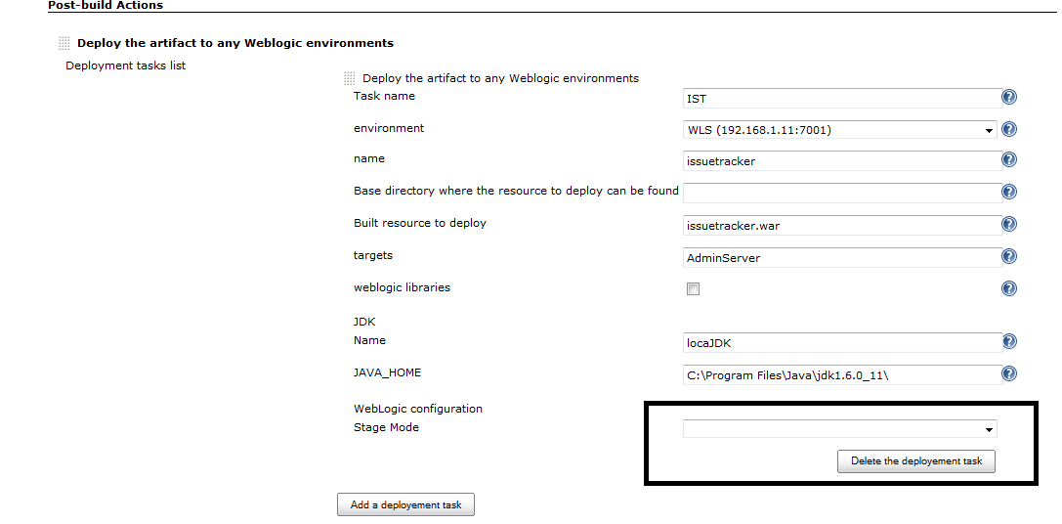

Error Trace:

javax.servlet.ServletException: java.lang.RuntimeException: Failed to instantiate class org.jenkinsci.plugins.deploy.weblogic.WeblogicDeploymentPlugin from {"tasks":{"taskName":"IST","weblogicEnvironmentTargetedName":"WLS","deploymentName":"issuetracker","baseResourcesGeneratedDirectory":" ","builtResourceRegexToDeploy":"issuetracker.war","deploymentTargets":"AdminServer","isLibrary":false,"jdkName":"locaJDK","jdkHome":"C:\\Program Files\\Java\\jdk1.6.0_11\\","stageMode":""},"mustExitOnFailure":false,"forceStopOnFirstFailure":false,"selectedDeploymentStrategyIds":[],"isDeployingOnlyWhenUpdates":false,"deployedProjectsDependencies":"","stapler-class":"org.jenkinsci.plugins.deploy.weblogic.WeblogicDeploymentPlugin","kind":"org.jenkinsci.plugins.deploy.weblogic.WeblogicDeploymentPlugin"}
at org.kohsuke.stapler.Stapler.tryInvoke(Stapler.java:719)
at org.kohsuke.stapler.Stapler.invoke(Stapler.java:770)
at org.kohsuke.stapler.MetaClass$6.doDispatch(MetaClass.java:241)
at org.kohsuke.stapler.NameBasedDispatcher.dispatch(NameBasedDispatcher.java:53)
at org.kohsuke.stapler.Stapler.tryInvoke(Stapler.java:677)
at org.kohsuke.stapler.Stapler.invoke(Stapler.java:770)
at org.kohsuke.stapler.Stapler.invoke(Stapler.java:583)
at org.kohsuke.stapler.Stapler.service(Stapler.java:214)
at javax.servlet.http.HttpServlet.service(HttpServlet.java:45)
at winstone.ServletConfiguration.execute(ServletConfiguration.java:248)
at winstone.RequestDispatcher.forward(RequestDispatcher.java:333)
at winstone.RequestDispatcher.doFilter(RequestDispatcher.java:376)
at hudson.util.PluginServletFilter$1.doFilter(PluginServletFilter.java:95)
at hudson.util.PluginServletFilter.doFilter(PluginServletFilter.java:87)
at winstone.FilterConfiguration.execute(FilterConfiguration.java:194)
at winstone.RequestDispatcher.doFilter(RequestDispatcher.java:366)
at hudson.security.csrf.CrumbFilter.doFilter(CrumbFilter.java:48)
at winstone.FilterConfiguration.execute(FilterConfiguration.java:194)
at winstone.RequestDispatcher.doFilter(RequestDispatcher.java:366)
at hudson.security.ChainedServletFilter$1.doFilter(ChainedServletFilter.java:84)
at hudson.security.ChainedServletFilter.doFilter(ChainedServletFilter.java:76)
at hudson.security.HudsonFilter.doFilter(HudsonFilter.java:164)
at winstone.FilterConfiguration.execute(FilterConfiguration.java:194)
at winstone.RequestDispatcher.doFilter(RequestDispatcher.java:366)
at org.kohsuke.stapler.compression.CompressionFilter.doFilter(CompressionFilter.java:50)
at winstone.FilterConfiguration.execute(FilterConfiguration.java:194)
at winstone.RequestDispatcher.doFilter(RequestDispatcher.java:366)
at hudson.util.CharacterEncodingFilter.doFilter(CharacterEncodingFilter.java:81)
at winstone.FilterConfiguration.execute(FilterConfiguration.java:194)
at winstone.RequestDispatcher.doFilter(RequestDispatcher.java:366)
at winstone.RequestDispatcher.forward(RequestDispatcher.java:331)
at winstone.RequestHandlerThread.processRequest(RequestHandlerThread.java:227)
at winstone.RequestHandlerThread.run(RequestHandlerThread.java:150)
at java.util.concurrent.Executors$RunnableAdapter.call(Unknown Source)
at java.util.concurrent.FutureTask$Sync.innerRun(Unknown Source)
at java.util.concurrent.FutureTask.run(Unknown Source)
at winstone.BoundedExecutorService$1.run(BoundedExecutorService.java:77)
at java.util.concurrent.ThreadPoolExecutor.runWorker(Unknown Source)
at java.util.concurrent.ThreadPoolExecutor$Worker.run(Unknown Source)
at java.lang.Thread.run(Unknown Source)
Caused by: java.lang.RuntimeException: Failed to instantiate class org.jenkinsci.plugins.deploy.weblogic.WeblogicDeploymentPlugin from {"tasks":{"taskName":"IST","weblogicEnvironmentTargetedName":"WLS","deploymentName":"issuetracker","baseResourcesGeneratedDirectory":" ","builtResourceRegexToDeploy":"issuetracker.war","deploymentTargets":"AdminServer","isLibrary":false,"jdkName":"locaJDK","jdkHome":"C:\\Program Files\\Java\\jdk1.6.0_11\\","stageMode":""},"mustExitOnFailure":false,"forceStopOnFirstFailure":false,"selectedDeploymentStrategyIds":[],"isDeployingOnlyWhenUpdates":false,"deployedProjectsDependencies":"","stapler-class":"org.jenkinsci.plugins.deploy.weblogic.WeblogicDeploymentPlugin","kind":"org.jenkinsci.plugins.deploy.weblogic.WeblogicDeploymentPlugin"}
at hudson.model.Descriptor.newInstance(Descriptor.java:602)
at hudson.model.Descriptor.newInstancesFromHeteroList(Descriptor.java:941)
at hudson.model.Descriptor.newInstancesFromHeteroList(Descriptor.java:926)
at hudson.util.DescribableList.rebuildHetero(DescribableList.java:203)
at hudson.model.Project.submit(Project.java:201)
at hudson.model.Job.doConfigSubmit(Job.java:1076)
at hudson.model.AbstractProject.doConfigSubmit(AbstractProject.java:758)
at sun.reflect.NativeMethodAccessorImpl.invoke0(Native Method)
at sun.reflect.NativeMethodAccessorImpl.invoke(Unknown Source)
at sun.reflect.DelegatingMethodAccessorImpl.invoke(Unknown Source)
at java.lang.reflect.Method.invoke(Unknown Source)
at org.kohsuke.stapler.Function$InstanceFunction.invoke(Function.java:288)
at org.kohsuke.stapler.Function.bindAndInvoke(Function.java:151)
at org.kohsuke.stapler.Function.bindAndInvokeAndServeResponse(Function.java:90)
at org.kohsuke.stapler.MetaClass$1.doDispatch(MetaClass.java:111)
at org.kohsuke.stapler.NameBasedDispatcher.dispatch(NameBasedDispatcher.java:53)
at org.kohsuke.stapler.Stapler.tryInvoke(Stapler.java:677)
... 39 more
Caused by: java.lang.IllegalArgumentException: Failed to instantiate class org.jenkinsci.plugins.deploy.weblogic.WeblogicDeploymentPlugin from {"tasks":{"taskName":"IST","weblogicEnvironmentTargetedName":"WLS","deploymentName":"issuetracker","baseResourcesGeneratedDirectory":" ","builtResourceRegexToDeploy":"issuetracker.war","deploymentTargets":"AdminServer","isLibrary":false,"jdkName":"locaJDK","jdkHome":"C:\\Program Files\\Java\\jdk1.6.0_11\\","stageMode":""},"mustExitOnFailure":false,"forceStopOnFirstFailure":false,"selectedDeploymentStrategyIds":[],"isDeployingOnlyWhenUpdates":false,"deployedProjectsDependencies":"","stapler-class":"org.jenkinsci.plugins.deploy.weblogic.WeblogicDeploymentPlugin","kind":"org.jenkinsci.plugins.deploy.weblogic.WeblogicDeploymentPlugin"}
at org.kohsuke.stapler.RequestImpl$TypePair.convertJSON(RequestImpl.java:596)
at org.kohsuke.stapler.RequestImpl.bindJSON(RequestImpl.java:391)
at org.kohsuke.stapler.RequestImpl.bindJSON(RequestImpl.java:387)
at hudson.model.Descriptor.newInstance(Descriptor.java:593)
... 55 more
Caused by: java.lang.IllegalArgumentException: Failed to convert the tasks parameter of the constructor public org.jenkinsci.plugins.deploy.weblogic.WeblogicDeploymentPlugin(java.util.List,boolean,java.util.List,java.lang.String,boolean,boolean,java.lang.String,java.lang.String,java.lang.String,boolean,java.lang.String,java.lang.String)
at org.kohsuke.stapler.RequestImpl$TypePair.convertJSON(RequestImpl.java:590)
... 58 more
Caused by: java.lang.IllegalArgumentException: Failed to instantiate class org.jenkinsci.plugins.deploy.weblogic.data.DeploymentTask from {"taskName":"IST","weblogicEnvironmentTargetedName":"WLS","deploymentName":"issuetracker","baseResourcesGeneratedDirectory":" ","builtResourceRegexToDeploy":"issuetracker.war","deploymentTargets":"AdminServer","isLibrary":false,"jdkName":"locaJDK","jdkHome":"C:\\Program Files\\Java\\jdk1.6.0_11\\","stageMode":""}
at org.kohsuke.stapler.RequestImpl$TypePair.convertJSON(RequestImpl.java:596)
at org.kohsuke.stapler.RequestImpl$TypePair.convertJSON(RequestImpl.java:632)
at org.kohsuke.stapler.RequestImpl.bindJSON(RequestImpl.java:391)
at org.kohsuke.stapler.RequestImpl$TypePair.convertJSON(RequestImpl.java:588)
... 58 more
Caused by: java.lang.IllegalArgumentException: Failed to convert the stageMode parameter of the constructor public org.jenkinsci.plugins.deploy.weblogic.data.DeploymentTask(java.lang.String,java.lang.String,java.lang.String,java.lang.String,java.lang.String,boolean,java.lang.String,java.lang.String,java.lang.String,java.lang.String,org.jenkinsci.plugins.deploy.weblogic.data.WebLogicStageMode)
at org.kohsuke.stapler.RequestImpl$TypePair.convertJSON(RequestImpl.java:590)
... 61 more
Caused by: java.lang.IllegalArgumentException: No enum constant org.jenkinsci.plugins.deploy.weblogic.data.WebLogicStageMode.
at java.lang.Enum.valueOf(Unknown Source)
at org.kohsuke.stapler.RequestImpl$TypePair.convertJSON(RequestImpl.java:646)
at org.kohsuke.stapler.RequestImpl.bindJSON(RequestImpl.java:391)
at org.kohsuke.stapler.RequestImpl$TypePair.convertJSON(RequestImpl.java:588)
... 61 more

