Copyartifact-plugin version 1.30
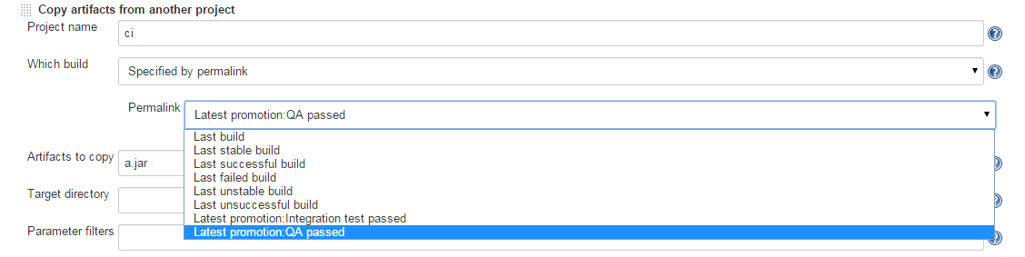

Copyartifact-plugin version 1.32.1 (no option and no completion…)
