Jenkins BlueOcean Issues

Agenda:
If you observe the below BlueOcean views, you can see that we are missing some Stages/Steps involved in the pipeline.

Expected BO view:

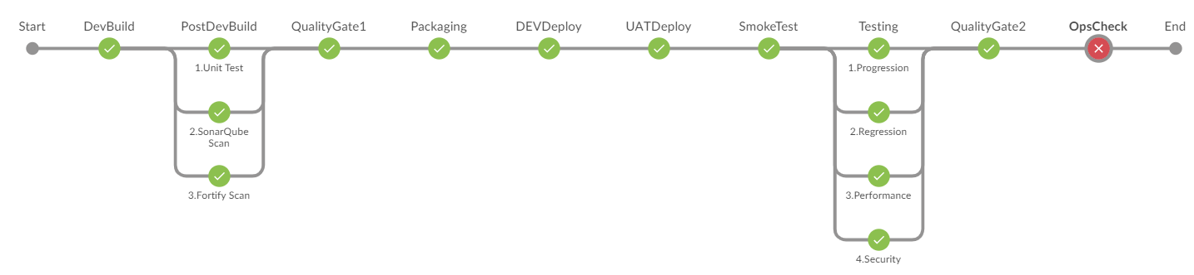

Evidence:

https://onejenkins.verizon.com/nts/blue/organizations/jenkins/NTS.B7EV.CICD.PIPELINES%2FNTS.PROC.VES.PROVCTRL.UAT.CD_PIPELINE_PROVCO-PC/detail/NTS.PROC.VES.PROVCTRL.UAT.CD_PIPELINE_PROVCO-PC/119/pipeline/
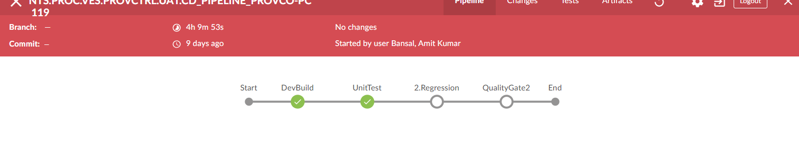

https://onejenkinscloud.vpc.verizon.com/nts/blue/organizations/jenkins/NTS.IVAV.VZIVAPP.UAT.DISPATCH_MS.CD_PIPELINE/detail/NTS.IVAV.VZIVAPP.UAT.DISPATCH_MS.CD_PIPELINE/235/pipeline
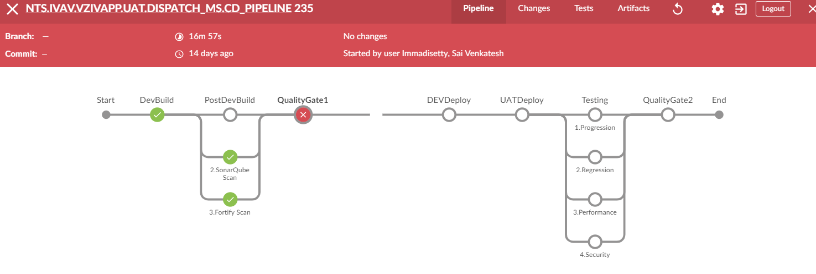

https://onejenkinscloud.vpc.verizon.com/nts/blue/organizations/jenkins/NTS.IVAV.VZIVAPP.UAT.DISPATCH_MS.CD_PIPELINE/detail/NTS.IVAV.VZIVAPP.UAT.DISPATCH_MS.CD_PIPELINE/243/pipeline
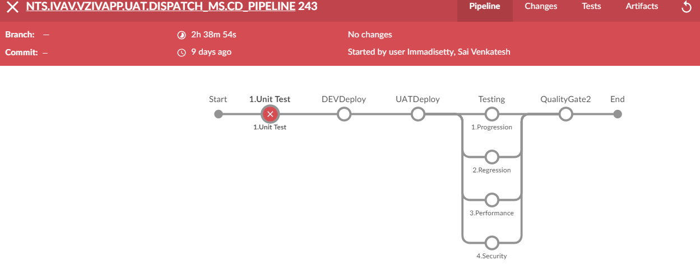

https://onejenkins.verizon.com/nts/blue/organizations/jenkins/NTS.B7EV.CICD.PIPELINES%2FNTS.PROC.VES.PROVCTRL.UAT.CD_PIPELINE_PROVCO-PC-AD/detail/NTS.PROC.VES.PROVCTRL.UAT.CD_PIPELINE_PROVCO-PC-AD/157/pipeline

